Use this handy QR Code or follow the instructions below.

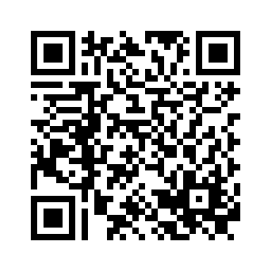

Instructions to activate the EMS Associates app in Ventla (iOS and Android Mobile App)

STEP 1: CLICK THE LINK TO DOWNLOAD THE APP
https://welcome.meetappevent.com/ems-associates?eventid=704188

Select “Open in mobile app”. Then click “Open” on the next page and you will be taken to the AppStore/Google Play Store to download the Ventla app. Make sure to allow push notifications when opening the app for the first time.

Note: If you’ve downloaded the app by searching the app store without using the above link, you will be asked for an additional app access code. The app access code is EMS9.

STEP 2: REGISTER AND VERIFY YOUR EMAIL
Register with your email and verify your email by entering the 4-digit code sent to your email from Ventla. Click next and you will be redirected to your event!

Instructions to access Ventla’s Virtual Venue (Web Platform on Computer)

RECOMMENDED BROWSER: GOOGLE CHROME
DO NOT USE FIREFOX

STEP 1: CLICK THE LINK TO ACCESS THE EVENT
https://welcome.ventla.io/ems-associates?eventid=702696

STEP 2: REGISTER AND VERIFY
Register with your email and verify your email by entering the 4-digit code sent to your email from Ventla. Click next and you will be redirected to your event! MAKE SURE TO ALLOW PUSH NOTIFICATIONS ON YOUR BROWSER FOR THIS WEBSITE.

